

Title or Task:

Description:

Files Required
Suitable for Classes: | AIT • Multimedia • Cert II IT • Cert II Bus
Area: | Technology & Enterprise
Teacher: | Mr Peter Faulks

Timeline

Date Due:

Task Brief:

Outcomes:

These pages are designed to show you how to use software packages; various software updates may have taken place so some pages will not apply to versions other than those listed here. In some cases data files may be required.

Items highlighted in yellow are tasks for you to complete
Items in Purple are help tips
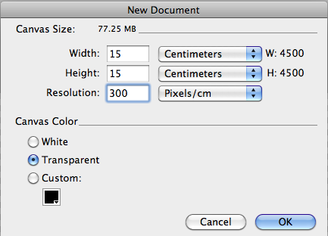
Using Fireworks Worksheet
Open Fireworks
Create a page 15cm by 15cm and 300dpi
Begin by using the Ellipse tool to draw a circle.
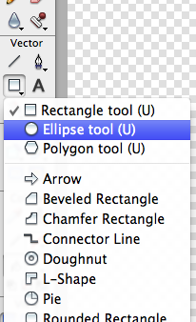
Next, you’ll use one of Illustrator’s grid tools, the Polar Grid, which uses arcs to produce concentric circles.

Then activate the Wrinkle tool to create uneven edges on an object. Select the Free Transform tool to distort the shape of a selected path or series of paths. And, for a final touch, use the Pen tool to draw some leaves.
There are a number of tools in Illustrator’s tool palette that allow you to develop your own stylized flowers. To create a flower hair clip like the one on the woman in our illustration,

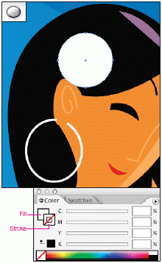
Launch Illustrator, choose Window > Color (F6). Set the Fill to White and the Stroke to None. Using the Ellipse tool (L), press Shift and drag to create a circle. In our example, we created the flower using an existing illustration.
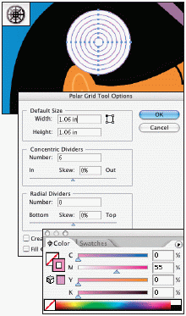
Double-click the Polar Grid tool. Use the options in the resulting Polar Grid Tool Options dialog box and click OK. Starting from the middle of the already existing circle, press Option + Shift and drag to create a Polar Grid Circle. In the Color palette, set the Fill to None and the Stroke to C:0; M:55; Y:0; K:0.
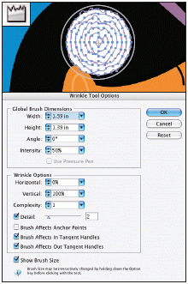
Double-click the Wrinkle tool. Use the options in the resulting Wrinkle Tool Options dialog box and click OK. Quickly click twice in the middle of the Polar Grid Circle.
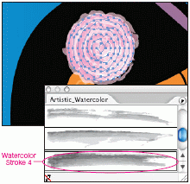
Choose Window > Brush Libraries > Artistic_ Watercolor. Choose Watercolor Stroke 4. Set the Stroke weight to .5 pt.
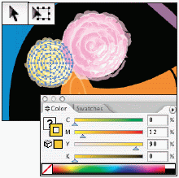
Choose Select > All (Command + A). Using the Selection tool (V), Optionclick the flower and drag to the left to duplicate it. Using the Free Transform tool (E), shift-click the lower left corner of the box and drag to reduce the size of the flower. Change the Stroke to C:0; M:12; Y:90; K:0 (left). Choose Object > Arrange > Send Backward (Command + [ ).
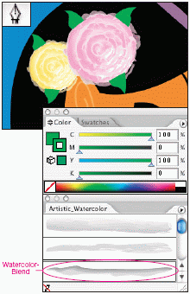
Choose Select > Deselect (Command + Shift + A). Set the Fill and Stroke to C:100; M:0; Y:100; K:0. Using the Pen tool (P), draw leaves around the flowers. Using the Selection tool (V), press Shift and select all the green leaves. In the Artistic_ Watercolor palette, choose Watercolor-Blend (far below, left). Set the Stroke weight to .5 pt. Choose Object > Arrange > Send Backward (Command + [ ).

Our final effect is shown at left.
http://www.graphics.com/modules.php?name=Sections&op=viewarticle&artid=482

